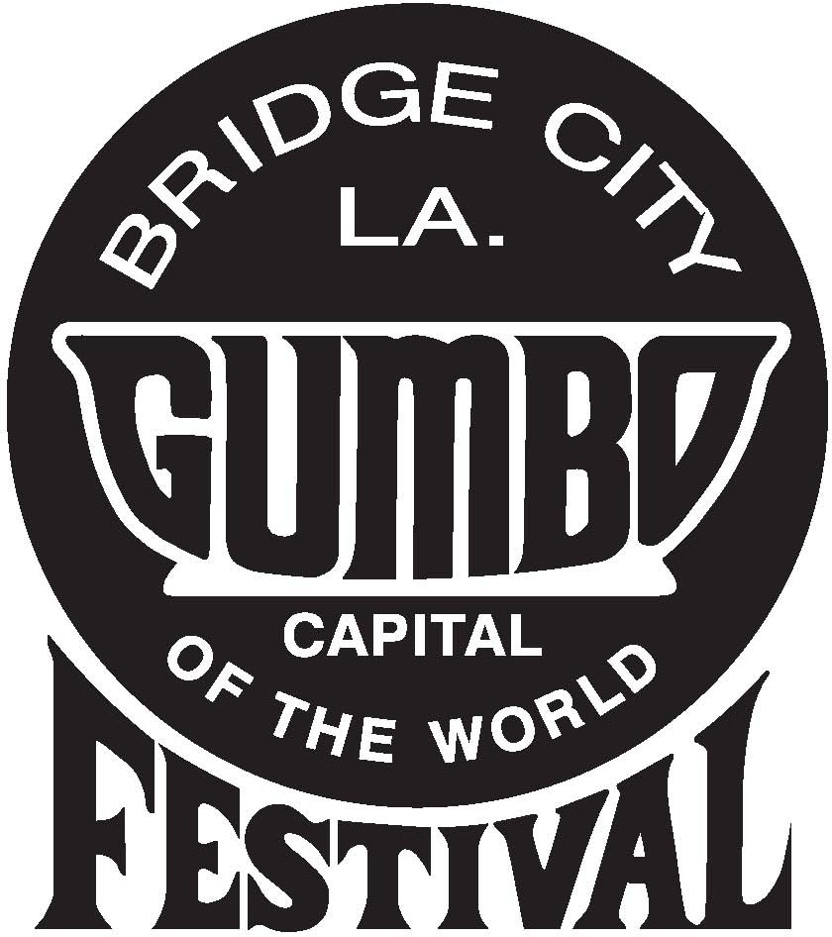

Gumbo Cooking Contest Entry Form

**Saturday October 14, 2023**

**Fill in the entry form below, and bring it with your gumbo entry.**

**PLEASE PRINT:**

Last Name First Name

Area Code Home Phone Area Code Cell Phone

e-mail address

Street Address City, State, Zip Code

Instructions:

Label container with your name & a list of ingredients used & bring at least ***ONE GALLON*** of your gumbo entry to The Gumbo Festival site, 1701 Bridge City Avenue, Bridge City, LA **before 12:00 noon** on **Saturday October 14, 2023**

**TYPE OF GUMBO ENTRY**

Please circle one:

**CHICKEN GUMBO SEAFOOD GUMBO**